Submitted to Mr Anwar Chutoo

University Of Mauritius

GROUP PROJECT: WEBSITE CREATION

Course name: BSc (Hons) Cybersecurity level Module code: ICT 2213(3) Web Technologies and Security

Fokeer Bhuvanesh 2412411

Catalina Anastasia Jacques 2412409

Bissessur Sehun 2412307

Mohes Shirish 2412091

Nazirkhan Amirah Wardah 2412156

Muhammad Ayman Shaikh 2412575

# Table of Contents

I. Table of Contents 1

II. Acknowledgement 3

III. Abstract 4

IV. Business Objective 5

A. Introduction 5

B. Criteria 5

V. Functional Requirements 6

A. Homepage 6

B. Appointment Management 6

C. Service Management 6

D. Doctor & vet profiles 6

E. Patient & pet owner records 7

F. Billing & Payment 7

G. Notification & Alerts 7

H. Staff & Admin Portal 7

I. Reporting 7

J. Contact 7

K. Extras 7

VI. Non-functional requirements 7

A. Performance 7

B. Security 8

C. Usability 8

D. Scalability 8

VII. UML Diagrams 9

A. Human UML Diagram 9

B. Pet UML Diagram 10

C. UML Activity Diagrams 11

VIII. ERD (Database Conceptual Model) 14

A. Entities 14

B. Relationships 15

IX. Highlight security checks (e.g., form validation, prevention of SQL injection). 16

A. Client-side 16

B. Server-side (Application Layer) 17

C. Database Layer 17

D. Hosting (Infrastructure layer) 17

# Acknowledgement

We, members of Cybertitan, would like to express our gratitude to everyone who guided us throughout the web project.

First, we thank our lecturer, Mr Anwar Chutoo for his insight, guidance and feedback which has helped us understand the aim of this project and deliver it.

We are also grateful for our faculty, Faculty Of Information, Communication and Digital Technology ( FoICDT) for providing us with this learning opportunity and the necessary resources available.

Lastly, we would like to acknowledge the group effort from our team members whose contributions were valuable, thus making this project possible.

# Abstract

The purpose of this document is to provide an overview of our web project which is a step-by-step process of the design and development of a Clinic Management System for VitalCare clinic. The clinic provides 2 different healthcare that offers medical services for humans and veterinary services for pets. Our system aims to provide a centralized platform for appointment scheduling, service management and pet medical records and biling.

Our system includes an interface for visitors where they can have an overview of the clinic and its services. Moreover, the customers can easily book appointments, access Doctors’ profiles, view available services and make secure online payments while the staff should be able to manage appointments, maintain records and produce an invoice/report.

With the implementation of the Clinic Management system, our aim is to reduce the manual workload, improve efficiency and boost the overall performance for both clients and staff. We also considered the fact that the system should also be scalable and user-friendly since most of the users will be Seniors Citizens, pregnant women and infants.

# Business Objective

## Introduction

VitalCare Clinic is a modern clinic offering healthcare services to humans including specialist treatments, diagnostic tests, general consultation and preventive care. They also provide veterinary care for pets such as grooming, checkups, vaccinations and surgeries. Their aim is making these services accessible and available to patients and pet owners, all under one motto “Your Health. Their Health. One Clinic.”. Over the years, VitalCare has grown to the point where it is difficult to make an appointment without waiting in long queues for hours. Moreover, appointments are often mixed up and patients are sometimes in conflict with their staff accusing them of incompetence.

With the growing demand for appropriate and hygienic healthcare and veterinary services, our team have decided to develop a clinic management system (CMS) for both human and pet clinics. With this approach, VitalCare should be able to operate on an online platform, hence aiding them in their management system and boost their efficiency. Moreover, this would increase their popularity and have a better reputation. The CMS benefits both the staff as well as patients and pet owners. They can book appointments online, hence no longer waiting in long lines. Staff will be able to manage services such as handling patient’s medical records, billing transactions or payment.

## Criteria

* **Visitors:** Visitors are basically the ones who will check out the services, reviews and feedback to get an overview of VitalCare.
* **Customers:** 2 types of customers as it will depend on the services.
  + **Human clinic**: medical services for patients depending on their disease and hence, a doctor/specialist will be appointed to them accordingly.
    - **Doctors can include**:
      * General Practitioners
      * Dermatologists
      * Cardiologists
      * Neurologists
      * Haematologists
      * Paediatricians
      * Gastroenterologist
      * Nephrologist
      * General Surgery
  + **Pet clinic**: veterinary services for pets depending on their disease and hence, a veterinarians will be appointed to them accordingly.
    - **Veterinarians can include**:
      * Dermatologists
      * Cardiologists
      * Neurologists
      * Surgery
      * Pathologists
      * Veterinary nutrition
      * Dentistry
* **Key personnels**
  + Patients
  + Pet owners
  + Doctors/veterinarians (to be specified)
  + Clinic receptionist
  + Nurses
  + Managers
  + System Administration (IT)
  + Visitors can be anyone

# Functional Requirements

## Homepage

* Overview of VitalClinic services (human & pet)
* Announcements (health tips, vaccination drives, promotions).
* QuickLinks to book an appointment.

## Appointment Management

* Prompt log in with credentials to check/ book an appointment via online booking. (can be patient or for an animal)
* Appointments can be rescheduled or cancelled.
* Send appointment reminders to patients/owners via email/SMS.
* Doctors can log in with credentials to check their open slots for future appointments.
* Nurses can log in to check which doctors need their assistance or which patients they have been assigned to take care of.
* Managers log in to check on operation of staffs

## Service Management

* Medical services available for humans:
  + Primary care (checkup, vaccinations, etc.)
  + Secondary care (Involves specialists)
  + Tertiary care (Requires advanced technology and experts)
* Pet care services
  + Grooming (bathing, fur brushing or trimming, etc.)
  + Vaccination
  + Surgery (spaying and neutering, anesthesia, laser surgeries, etc.)
* Filter by human or pet, category (service required), price, duration

## Doctor & vet profiles

* Display doctor id/ veterinarian id, name, qualifications, specialization, contact number, experience.
* Show available hours, room
* Patient/pet owner feedback

## Patient & pet owner records

* Patient id, patient name, age, sex, disease, contact number, address
* Pet id, pet name, owner name, species, sex
* Medical history for both

## Billing & Payment

* Service price list
* Automatic invoice generated and sent via email/SMS
* Multiple payment methods:
  + Cash
  + Credit/debit card
  + Online (juice, blink, etc.)
* Receipt after each payment. Client must do 50% down payment for booking appointments and other 50% on day on appointment.

## Notification & Alerts

* Appointment confirmation/reminders
* Invoice & payment receipt
* Service promotions & offers. (Ex. Registered patients have 10% discount if they have a pet registered as well.)

## Staff & Admin Portal

* Role-based access control (system admin, manager, doctor, nurse, receptionist)
* Alter/Add/Remove services and schedules
* View appointments & reports.
* Manage patients & pet medical records.

## Reporting

* Monthly automated report generated and sent to Manager only.
* Statistics on clients. (feedback, client preference, etc.)

## Contact

* Emergency hotline
* Location of the clinics

## Extras

* Blog/ Health Tips section (for both humans & pets).
* Feedback and rating system

# Non-functional requirements

## Performance

* Time to load appointments < 3 seconds
* Time to receive invoices and receipts
* Ability to handle 100 users per minute (exaggerated amount.)
* Faulty/ missing equipment should not significantly impact performance.

## Security

* Medical history, financial transactions, contact information encrypted; RBAC
* Create backups every now and then.
* Multi factor authenticator. (biometric, facial recognition, OTP, scan to log in)
* Password policy for staff to change password every 90 days (3 months)

## Usability

* Clients should be able to navigate easily. (user-friendly UI for both human and pet clinic customers)
* Staff should be able to manage the system easily. Too much complexity will make it ineffective.

## Scalability

* System should be able to support more users/ multiple branches in the future.

# UML Diagrams

## Human UML Diagram

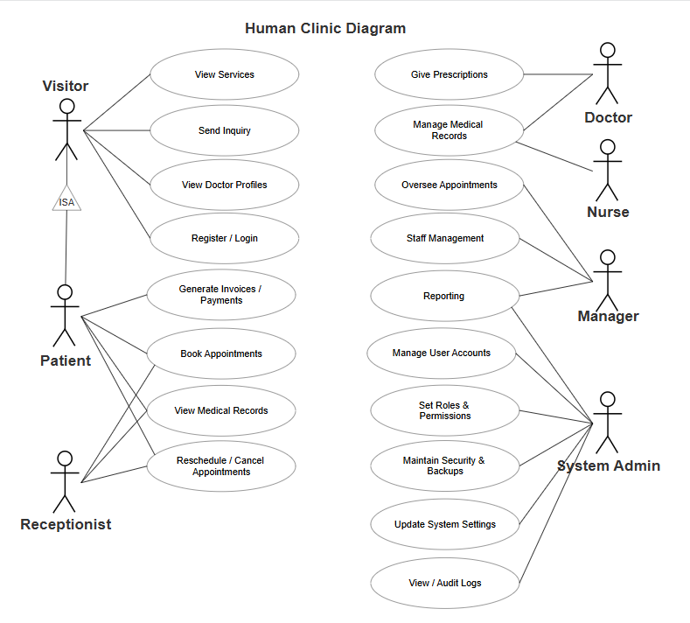**Figure 1: ’Human Clinic’ Use Case Diagram**

## Pet UML Diagram

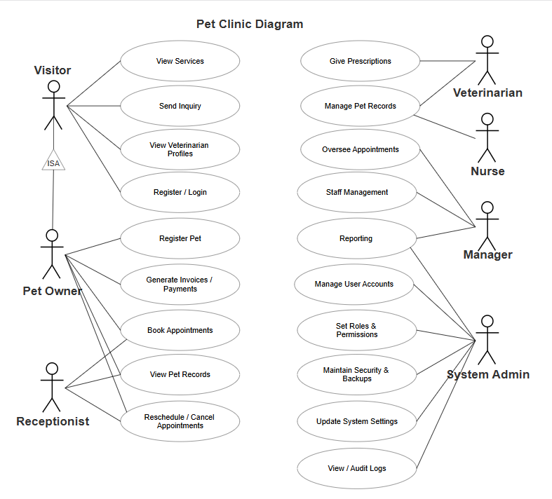**Figure 2: ’Pet Clinic’ Use Case Diagram**

## UML Activity Diagrams

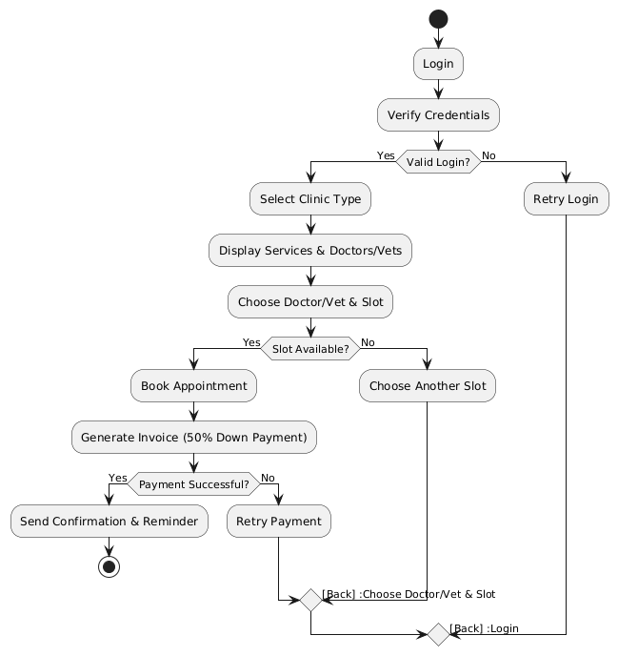

**Figure 3: ‘Booking appointment’ Activity Diagram**

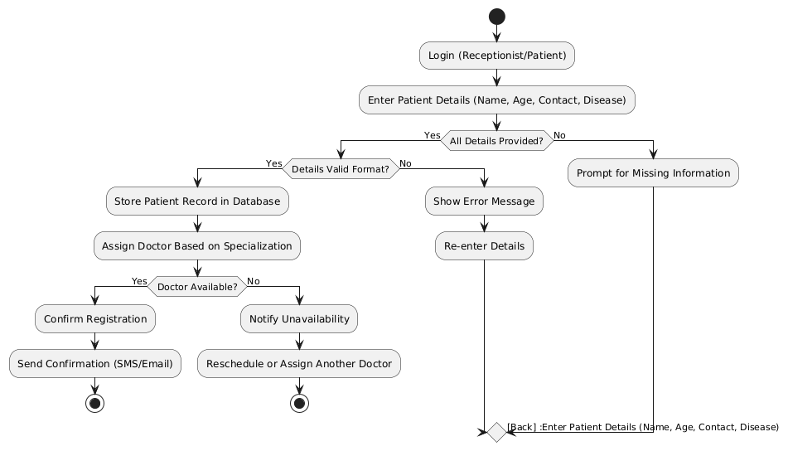

**Figure 4: ‘Registering a patient’ Activity Diagram**

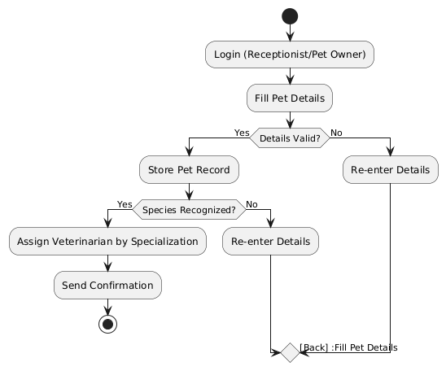

**Figure 5: ‘Registering a pet’ Activity Diagram**

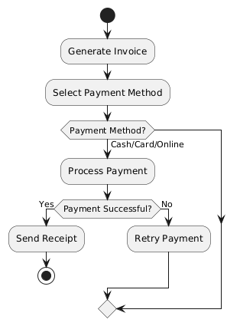

**Figure 6: ‘Billing & Payment’ Activity Diagram**

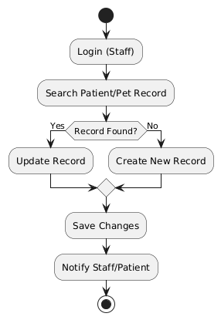

**Figure 7: ‘Medical Record Management’ Activity Diagram**

# ERD (Database Conceptual Model)

Based on the business objectives and functional requirements, I have constructed an **ERD** (Conceptual Model). Below are some entities and relationships for the ERD.

## Entities

* **Patients**
* PatientID (PK)
* Name
* Age
* Gender
* ContactNo
* Address
* MedicalHistory
* **PetOwners**
* OwnerID (PK)
* Name
* ContactNo
* Address
* **Pets**
* PetID (PK)
* Name
* Species
* Breed
* Gender
* MedicalHistory
* OwnerID (FK linked to PetOwners.OwnerID)
* **Doctors**
* DoctorID (PK)
* Specialization
* Qualification
* Availability
* **Services**
* ServiceID (PK)
* ServiceName
* Category (Human / Pet)
* Price
* Duration
* **Appointments**
* AppointmentID (PK)
* Date
* Time
* Status (Booked / Cancelled / Completed)
* PatientID (FK linked to Patients.PatientID, null if PetID is used)
* PetID (FK linked to Pets.PetID, null if PatientID is used)
* DoctorID (FK linked to Doctors.DoctorID)
* ServiceID (FK linked to Services.ServiceID)
* **Payments**
* PaymentID (PK)
* AppointmentID (FK linked to Appointments.AppointmentID)
* Amount
* PaymentMethod (Cash / Card / Online)
* Status (Pending / Completed)
* ReceiptNo
* **Staff (Optional, for Admin Portal)**
* StaffID (PK)
* Name
* Role (Receptionist, Nurse, Manager, Admin)
* ContactNo
* Credentials

## Relationships

* **PetOwners ONE TO MANY Pets** (One owner can have multiple pets).
* **Patients ONE TO MANY Appointments** (Each patient can book many appointments).
* **Pets ONE TO MANY Appointments** (Each pet can have many appointments).
* **Doctors ONE TO MANY Appointments** (Doctor attends many appointments).
* **Services ONE TO MANY Appointments** (Each service can be linked to many appointments).
* **Appointments ONE TO ONE Payments** (Each appointment generates one payment transaction).
* **Staff MANY TO MANY Services** (Staff/Admins can manage multiple services; services can be handled by multiple staff).

Here’s the **Entity-Relationship Diagram (ERD)** for the VitalCare Clinic system:

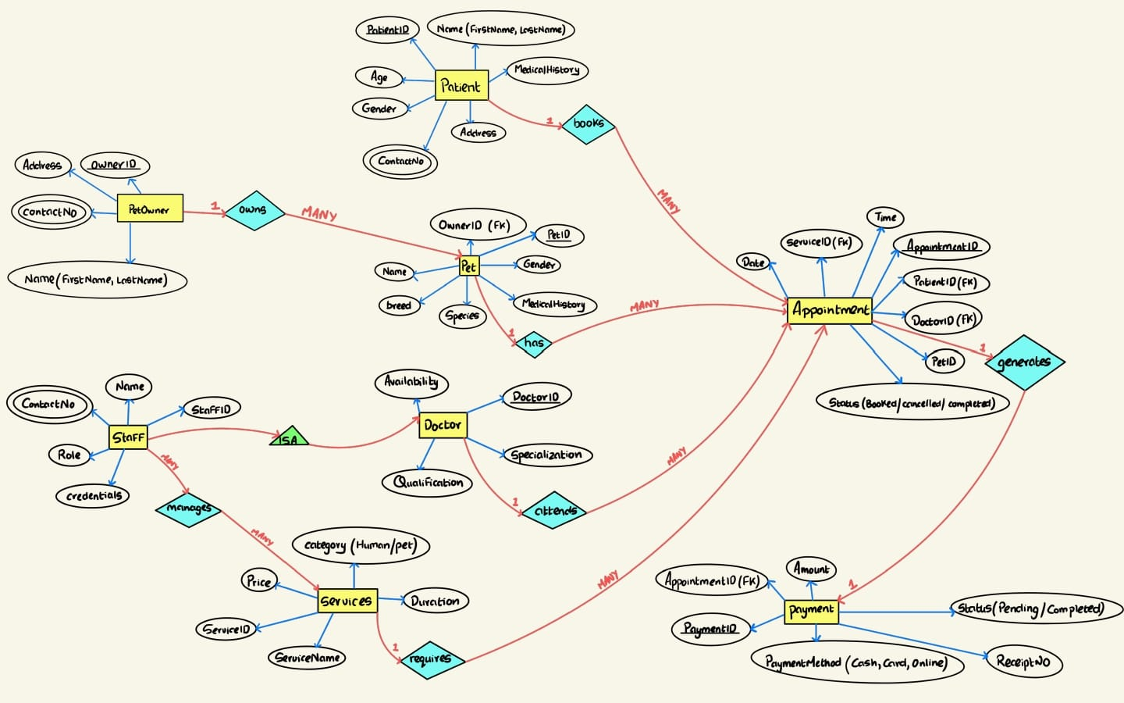

# Highlight security checks (e.g., form validation, prevention of SQL injection).

Security is necessary in multiple layers: client-side, server-side, database and hosting.

## Client-side

* Form validation on the browser
* Input sanitization before sending to server
* Prevent XSS with **Content Security Policy (CSP),** which is a security header that will tell the browser the sources of contents which are allowed to load and execute.

## Server-side (Application Layer)

* Multi-factor authentication (MFA) should be implemented in sensitive areas which consider login & authentication and sensitive data such as the records of patients and animals.
* A session management system should be put in place to regenerate session IDs and session timeout/inactivity logout.
* Prepared statements should be used to mitigate the risk of an SQL injection,as they separate the SQL logic from user input.

## Database Layer

* Defining a whitelist of what inputs are allowed on database queries to mitigate the risk of SQL injection and application errors.
* The implementation of the Least Privilege Principle to limit the damage if the web page is compromised.
* Regular backups should be done periodically so as whenever there is a risk for compromised data/solen data, it can be retrieved from a clean backup.

## Hosting (Infrastructure layer)

* Logging and monitoring are important as it will detect intrusions earlier and help in incident response.
* SSH is used to remotely manage servers; it prevents password theft and is unbreakable by brute force.
* Disabling unnecessary services and unused ports is a preventive control to be made to reduce the attack surface and the risk of unauthorized access.